

Report 1

Members:

Justin Goulet, Chris Larsen, Mikal Callahan, Brock Corbett

Table of Contents

Project Kickoff 5

Summary of Accomplishments: 5

Objectives of Next Phase: 5

Accrued Cost: 5

Estimated Cost: 5

Application Development 6

Statement of Business Context: 6

Statement of the Customer's Business Problem: 6

Statement of Project Proposal 6

Statement of Deliverables 6

What Medium Will the Product be Delivered in: 6

Outline of Project Measures of Success 6

Workflow Representation: 7

Requirements Matrix 8

Project Plan 9

Project Management 10

Section Objective 10

Introduction 10

Roles and Responsibilities 10

Project Sponsor / Director 10

Project Manager 10

Key Stakeholders 10

Project Team 10

Project Team Leader 11

Steering Committee 11

Plan Communications Management 11

Manage Communications 12

Control Communications 13

Initial Project Cost Tracking Chart 13

Statement of the Deliverables 14

Gantt Chart of Phases 14

Resources Outline 15

What resources we will need from Northrop Grumman: 15

What resources we are supplying: 15

What resources we will need from the instructor: 15

Appendix A - Project Team Directory 16

Appendix B - Communications Matrix 18

Appendix C - Weekly Time Sheets 19

WEEK 2  1/29 - 2/4 19

WEEK 3 2/5 - 2/11 20

Team Information 22

Team Norms 22

Reliability 22

Commitment 22

Communication 22

Common Goal 22

Stakeholder Approval 25

Usrey, Thomas (Ty)

Northrop Grumman

16765 W. Bernardo Dr.

San Diego, CA 92127

Dear Mr. Usrey,

Hello, and welcome, to our Spring 2017 CSUSM Senior Project. We are looking forward to working together on this project and thank you for your support in allowing us to participate in your company task(s).

Before we dive into the project, I want to first introduce our team, Vortek Solutions. Many of us, myself included, worked together last semester on our own hosted website, BeerHopper.me. The creation of this website not only advanced our basic web skills, it advanced our relationships with one another to become a dedicated team.

While we all come from different backgrounds, we all have the same goal: to ensure you, our client, receives a project completed to the best of our ability that meets your pre-determined requirements.

Finally, while this is the majority of our team’s last semester before our Bachelors of Science degrees, we want to place our best feet forward and hope to work with you on your project as this is our best opportunity to present ourselves with real-world meetings, requirements and time management skills. We are an extremely dedicated team who wish to work with you on any alterations, deadline adjustments or functionality shifts that may arise - so long as it is in the defined Project Director’s scope.

If you have any questions or concerns in the duration of the project, please do not hesitate to message us in Slack® or email us with the address shown below. Thank you.

Justin Goulet

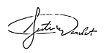

Project Manager / Lead

CIS 490 CSUSM

Project Management & Implementation

[VortekSolutions.CIS@gmail.com](mailto:VortekSolutions.CIS@gmail.com)

CC: Dr. Shaun-Inn Wu

# Project Kickoff

## Summary of Accomplishments:

* Defined requirements:
  + What the widget is trying to accomplish (visualize workflow requirements)
  + Design requirements (e.g. colors, fonts, layout)
  + Performance requirements (e.g. error checking, data storage)
* Discussed communication methods
  + Ty now has access to specific slack channels
  + Ty has also been granted read access to our github channel
* Discussed how final product will be demoed
* Discussed project priorities (in order)
  + Workflow
  + Scheduling
  + Layout

## Objectives of Next Phase:

* Adjust requirements based on client feedback if necessary
* Finalize definition of workflow object
* Research and document possible technologies that could be used to solve the business problem
* Begin design of wireframes for widget

## Accrued Cost:

Consultation Fee ($35/hour):

1 hours * $35 = $35

Labor Fee ($25/hour):

10 hours * $25 = $250

$250/4 team members = $62.5 per team member

## Estimated Cost:

Labor Fee ($25/hour):

12 weeks * 10 hours per week * 4 employees = 480 hours

480 hours *$25 = $12000

Client Signature: _____________________________ Date: ____ /____ /________

# Application Development

## Statement of Business Context:

Northrop Grumman has existing systems related to their manufacturing workflows. These systems run in a web browser showing statistics and information related to specific workflows. Created statistics are visualized in charts, or Visio style diagrams, which are not always easily read (especially on devices of various screen sizes such as the tablets used by upper management). The statistics and other pieces of information related to the workflows are then used in decision making at various levels throughout the organization.

## Statement of the Customer's Business Problem:

Northrop Grumman is in need of a versatile widget that would allow them to monitor their current workflow in an easy to process but highly descriptive manner. Currently the employees get this information printed out on a piece of a paper, but if we can provide a digital solution to this issue, this widget will help them identify areas in their workflow that are prone to delays or holdups, as well as areas that tend to be quicker than anticipated. This will help the company easily analyze its workflow processes.

## Statement of Project Proposal

We propose a widget that will be able to receive multiple workflow objects and render it in the multiple browsers that Northrop Grumman supports. The widget will also be able to be styled using CSS and have the ability to add, update and edit a workflow’s state.

## Statement of Deliverables

The deliverables will be:

* The final widget which will:
  + An executable, locally run widget, which interprets JSON data containing information of a specific workflow
  + Display workflows in a visual manner
  + Run on IE11+, Firefox 45+ and Edge.
* Documentation
* Source Code

## What Medium Will the Product be Delivered in:

Source code that our clients at Northrop Grumman will be able to compile and run on their local machines via web browser (IE11+, Edge, Firefox45+)

## Outline of Project Measures of Success

We will know that we have finished the widget when (after extensive testing) we are able to read in a JSON object full of workflow information and correctly display said workflow. The widget will also need to be dynamic in the sense that the user will have the ability to add, remove, or modify existing states from said workflow.

# Workflow Representation:

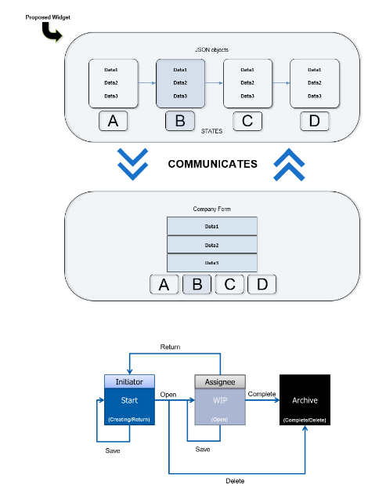

# Requirements Matrix

|  |  |  |  |  |
| --- | --- | --- | --- | --- |
| Requirement # | Requirement | Diagram # | Module Name | Implemented  (Y/N) |
| 1 | Receive JSON data from source |  |  |  |
| 2 | Widget must run on IE 11+ |  |  |  |
| 3 | Widget must run on Edge |  |  |  |
| 4 | Widget must run on Firefox 45+ |  |  |  |
| 5 | Render projected workflow steps |  |  |  |
| 6 | Render workflow info (project name, date started, etc) |  |  |  |
| 7 | Render workflow step linkages |  |  |  |
| 8 | Allow workflow’s current state to be changed to a different state |  |  |  |
| 9 | Allow additional state(s) to be added to the workflow |  |  |  |
| 10 | Allow states to be deleted |  |  |  |
| 11 | Allow widget to be themed with CSS |  |  |  |
| 12 | Widget must be able to handle JSON objects with incomplete data |  |  |  |

# Project Plan

* Hold JAD 1 Meeting (2/9/17)
* On site
* Discuss communication methods
* Define customer requirements
* Interpret project priorities
* Discuss final product
* Hold JAD 2 Meeting (2/23/17)
* On site
* Adjust requirements if needed
* Examine possible technologies to implement
* Finalize definition of workflow object
* Hold Prototype Meeting 1 (3/16/17)
* On site
* Widget can accept JSON objects
* Widget display implemented
* Get feedback
* Hold Prototype Meeting 2 (4/13/17)
* On site
* Widget given more functionality (modify/delete)
* CSS themed
* Error-handling
* Get more feedback for final product

# Project Management

## Section Objective

To provide insight to the client as to how the project will be completed and to ensure consistency between client-team communications and management.

## Introduction

This project is to be conducted by the team Vortek Solutions from California State University, San Marcos in conjunction with Thomas (Ty) Usrey, representing Northrop Grumman.

The project requirements, outlined in this document, provide the functionality of the proposed system that the university must accomplish for successful submission. The project, as mentioned, is to either create or modify an existing system in order to match the outlined requirements. Starting with a widget for project workflow, this project will, if time permits, advance to additional resources such as a scheduler and layout (Visio-style) application.

## Roles and Responsibilities

### Project Sponsor / Director

The project sponsor is the champion of the project and has authorized the project by signing the project charter.  This person is responsible for the funding of the project and is ultimately responsible for its success.  Since the Project Sponsor is at the executive level, communications should be presented in summary format unless the Project Sponsor requests more detailed communications.

### Project Manager

The Project Manager has overall responsibility for the execution of the project. The Project Manager: manages day to day resources, provides project guidance and monitors, and reports on the projects metrics as defined in the Project Management Plan. As the person responsible for the execution of the project, the Project Manager is the primary communicator for the project distributing information according to the provided Communications Management Plan.

### Key Stakeholders

Normally Stakeholders includes all individuals and organizations that are impacted by the project.  For this project we are defining a subset of the stakeholders as Key Stakeholders.  These are the stakeholders with whom we need to communicate with and are not included in the other roles defined in this section. The Key Stakeholders includes executive management with an interest in the project and key users identified for participation in the project.

### Project Team

The Project Team is comprised of all persons who have a role performing work on the project.  The project team needs to have a clear understanding of the work to be completed and the framework in which the project is to be executed. Since the Project Team is responsible for completing the work for the project, they play a key role in creating the Project Plan including defining its schedule and work packages. The Project Team requires a detailed level of communications which is achieved through day to day interactions with the Project Manager and other team members along with weekly team meetings.

### Project Team Leader

The project team leader will organize and control the critical portions of the project and reports directly to the project sponsor. The project team leader organizes team meetings, imperative documents that contribute to the success of the project, and manages the external communications within the project team.

The project team leader receives the reports from the scheduled automated reports and analyzes the team’s current situation in respect to the status of the overall project, as well as the prospected modules incorporated within. With the information gathered, the team leader will then adjust schedules, allocate resources, and advance the ongoing project in appropriate areas.

### Steering Committee

The Steering Committee includes management representing the departments which make up the organization. The Steering Committee provides strategic oversight for changes which impact the overall organization. The purpose of the Steering Committee is to ensure that changes within the organization are affected in such a way that it benefits the organization as a whole.  The Steering Committee requires communication on matters which will change the scope of the project and its deliverables.

## Plan Communications Management

The plan communications management process will develop the approach and plan for project communications based on stakeholder information needs and requirements, as well as using available assets of the organization. Key to this planning process is documenting an approach that results in the highest possible number of stakeholders receiving the most effective, efficient communications possible.

The communications management plan answers questions such as:

* Who needs what information?
* When do they need the information?
* Where will information be stored?
* In what format(s) will information be stored?
* How will information be retrieved?

Inputs to the plan communications management are Project Management Plan, Stakeholder register, Enterprise environmental factors, and Organizational process assets.

The tools and techniques utilized to plan communications management include Communication requirements analysis, Communication technology, Communication models, Communication methods, and Meetings. The PM must take an active role in ensuring effective communications occur on the project.

Team roles and communications will be documented in ***Appendix A*** for referral by team members. Communications requirements will be documented in the communications matrix, shown in ***Appendix B***.

The choice of technology with which to communicate is highly important. For the Workflow Widget project, the communications technologies will be email, web conferencing, Slack, GitHub and MS Project.  The model will take into account standard communications model of Microsoft Project and will overcome its limitations by monitoring communication process and identifying gaps in communication. The secondary systems used will allow the project team to communicate as soon as possible with associated mobile applications, reminders of tasks, and ease of document sharing as drafts are created.

For Slack and GitHub repo access, contact the PM for setup instructions.

Available communications methods considered for the Workflow Widget project include Interactive communication and Push communication, and the chosen methods are meetings, phone calls, video conferencing, emails, and summary reports.

The output of the plan communications management process is the communications management plan. Other project documents receiving updates include the project schedule and stakeholder register.

## Manage Communications

In addition to the communications management plan, the inputs to the manage communications process include Work performance reports, Enterprise environmental factors, and Organizational process assets. Project communication activities must occur within the limitations imposed by the approved budget, schedule, and resource allocations. The project manager is responsible for ensuring that communication activities are performed by the project team and without using other resources which could cause a budget overrun. Communication activities will occur in accordance with the frequencies detailed in the Communication Matrix in order to ensure the project adheres to schedule constraints.

The tools and techniques to be employed to manage communications include Communication technology, communication methods, and performance reporting. All project documents will be stored in a private GitHub repository with version control. Standardized formats and templates existing in the organization may be used for communications related to the Workflow Widget project. Where necessary, additional formats and templates may need to be developed.

Organizational process assets such as the information management policy will be used to govern such things as the distribution of confidential information. The PM is responsible for ensuring that proper protocols are followed.

The outputs of the manage communication process include Project Communications, Project management plan update, Project Document update, and Organizational process assets update.

## Control Communications

The inputs to the control communications process include Project Management Plan, Project Communications, Issue log, work performance data, and Organizational process assets. These will ensure that key issues such as performance indicators, issues, schedule, costs and scope performance are identified and included in project communications.

The tools and techniques applied to the control communications process include Information Management systems, expert judgement, and meetings.

The outputs of the control communications process include Work performance information, Change requests, Project management plan, Project Document updates, and Organizational process asset updates and will ensure that project communication is controlled, documented, and performed.

# Initial Project Cost Tracking Chart

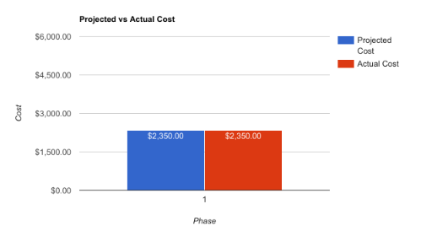

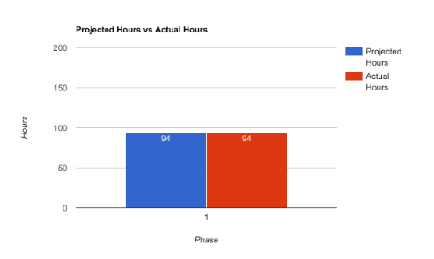

## Statement of the Deliverables

**In the next phase,** our plan is to gather information on new technologies in order to find out what will suit our project the best. If we are able to finalize a technology to implement, our next task is to start working on the mockup for the widget. This includes design and documentation, which will eventually lead to implementation in the following phase.

#### **Estimated Costs - Phase 2 Due Date: 2/23/17**

|  |  |  |  |
| --- | --- | --- | --- |
| **Task** | **Hours** | **Bill Rate** | **Total Cost** |
| Explore new technologies for widget | 40 | $25.00 | $1,000.00 |
| Create mockup for widget | 40 | $25.00 | $1,000.00 |
| **Total Hours:** | 80 | $25.00 | $2,000.00 |

## Gantt Chart of Phases

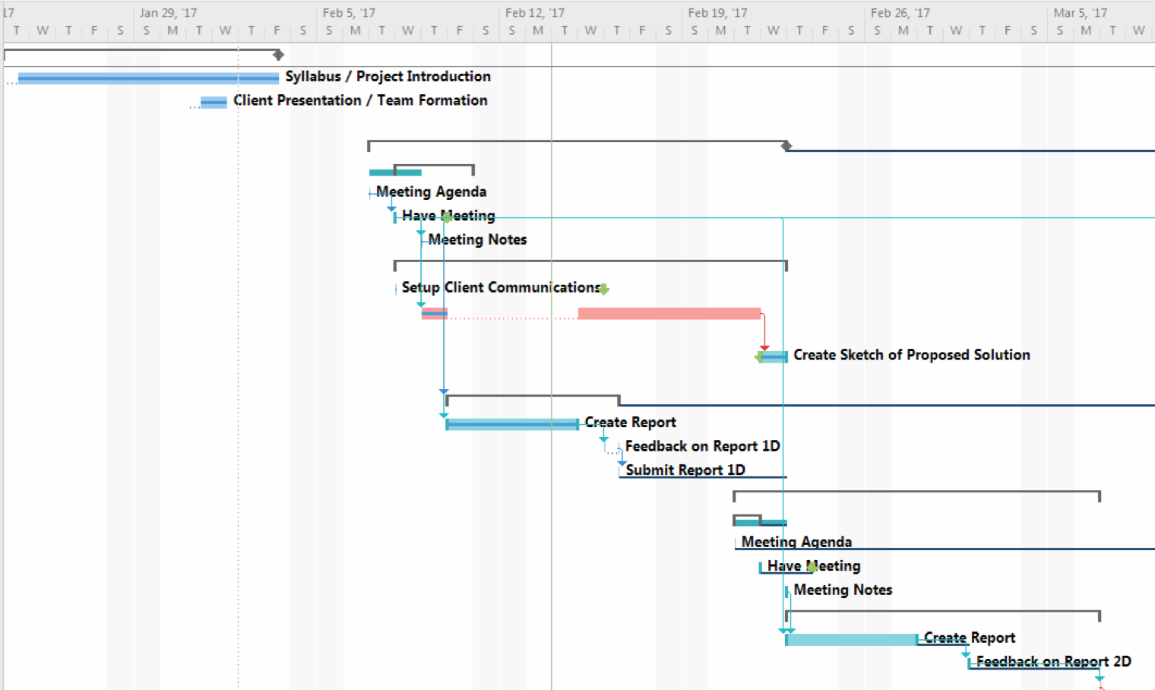

## Resources Outline

### What resources we will need from Northrop Grumman:

* Due to the nature of Northrop Grumman’s industry/clientele we understand that we will have no access to Northrop’s internal network and production data.
* Ty has provided us with:
  + Sample workflow object data
  + Application style guide
  + List of commercial libraries that Northrop Grumman has access to.

### What resources we are supplying:

* We will provide a test environment to mimic how the widget will be deployed in production.
* Any open source software that is needed for research/ development purposes.
* Slack channel
* GitHub repository

### What resources we will need from the instructor:

* At this time we do not require anything of the instructor.

## Appendix A - Project Team Directory

The following table presents contact information for all persons identified in this communications management plan. The email addresses and phone numbers in this table will be used to communicate with these people.

|  |  |  |
| --- | --- | --- |
|  |  |  |
| **Project Sponsor / Director** | **Name:** | Dr. Shaun-Inn Wu |
|  | **Organization:** | California State University, San Marcos (CSUSM) |
|  | **Email:** | shauninn@csusm.edu |
|  | **Phone:** | *Unknown* |
|  |  |  |
| **Project Team** | **Organization:** | CSUSM |
|  | **Email:** | VortekSolutions.CIS@gmail.com |
|  |  |  |
| **Project Manager** | **Name:** | Justin Goulet |
| **Project Team Leader** | **Organization:** | CSUSM |
| **Project Team Member** | **Email:** | goule001@cougars.csusm.edu |
|  | **Primary Task:** | Management & Documentation |
|  | **Phone:** | (760) 221 - 2699 |
|  |  |  |
| **Project Team Member** | **Name:** | Chris Larsen |
|  | **Organization:** | CSUSM |
|  | **Email:** | larse030@cougars.csusm.edu |
|  | **Primary Task:** | UX, Development |
|  | **Phone:** | (760) 504 - 8477 |
|  |  |  |
|  |  |  |
|  |  |  |
|  |  |  |
| **Project Team Member** | **Name:** | Mikal Callahan |
|  | **Organization:** | CSUSM |
|  | **Email:** | calla033@cougars.csusm.edu |
|  | **Primary Task:** | UI/UX, Development |
|  | **Phone:** | (760) 580 - 5528 |
|  |  |  |
| **Project Team Member** | **Name:** | Brock Corbett |
|  | **Organization:** | CSUSM |
|  | **Email:** | corbe009@cougars.csusm.edu |
|  | **Primary Task:** | Development |
|  | **Phone:** | (760) 807- 8067 |
|  |  |  |
| **Steering Committee** | **Name:** | Thomas (Ty) Usrey |
|  | **Organization:** | Northrop Grumman |
|  | **Email:** | thomas.usrey@ngc.com |
|  | **Phone:** | *Unknown* |
|  |  |  |
| **Key Stakeholder(s)** | See Stakeholder Register (Not Yet Created) | |
|  |  |  |

## Appendix B - Communications Matrix

|  |  |  |  |  |  |
| --- | --- | --- | --- | --- | --- |
| Communication Type | Kickoff Meeting | Project Team Meetings | Technical Design Meetings | Status Meetings | Project Status Reports |
| Objective of Communication | Introduce the project team and the project.  Review project objectives and management approach. | Integrate research, design and implementation | Discuss and develop technical design solutions for the project | Report on the status of the project to director | Report the status of the project including activities, progress, costs and issues |
| Medium | Face to Face | Face to Face,  Online Meeting | Face to Face,  Online Meeting | Online Meeting | Online |
| Frequency | Once | Weekly | Weekly | Weekly / Monthly | Weekly |
| Audience | Project Team, Sponsor, Steering Committee | Project Team | Project Team | Project Team,  Project Sponsor | Project Team,  Project Sponsor,  Steering Committee |
| Owner | Steering Committee | Project Manager | Project Manager | Project Sponsor | Project Manager |
| Deliverable | Agenda,  Meeting Notes | Project Status | Section included in “Project Status Reports” | Report Drafts | Summarized Weekly Status Reports |
| Format | Northrop Office | CSUSM - Informal | Skype / CSUSM - Informal | Skype | Email / Slack |

## Appendix C - Weekly Time Sheets

### WEEK 2        1/29 - 2/4

|  |  |  |  |  |  |  |  |  |  |  |
| --- | --- | --- | --- | --- | --- | --- | --- | --- | --- | --- |
| Justin Goulet | | | | | | | | | | |
| Week | Tasks | | | Projected Hours | | Actual Hours | | Difference(+/-) | | Task Completed |
| 2 | Research | | | 2 | | 2 | | 0 | | y |
|  | Project Initialization | | | 3 | | 6 | | 3 | |  |
| Chris Larsen | | | | | | | | | | |
| Week | | Tasks | Projected Hours | | Actual Hours | | Difference(+/-) | | Task Completed | |
| 2 | | Research | 2 | | 2 | | 0 | | y | |
| Mikal Callahan | | | | | | | | | | |
| Week | | Tasks | Projected Hours | | Actual Hours | | Difference(+/-) | | Task Completed | |
| 2 | | Research | 2 | | 2 | | 0 | | y | |
| Brock Corbett | | | | | | | | | | |
| Week | | Tasks | Projected Hours | | Actual Hours | | Difference(+/-) | | Task Completed | |
| 2 | | Research | 2 | | 2 | | 0 | | y | |

J. Goulet:       _____________________________ Date: ____ /____ /________

C. Larsen:      _____________________________ Date: ____ /____ /________

M. Callahan:  _____________________________ Date: ____ /____ /________

B. Corbett:     _____________________________ Date: ____ /____ /________

### WEEK 3 2/5 - 2/11

|  |  |  |  |  |  |  |  |  |  |  |  |  |  |
| --- | --- | --- | --- | --- | --- | --- | --- | --- | --- | --- | --- | --- | --- |
| Justin Goulet | | | | | | | | | | | | | |
| Week | Tasks | Projected Hours | | Actual Hours | | | | | Difference(+/-) | | | | Task Completed |
| 3 | Research Workflow Solutions & Documentations | 12 | | 12 | | | | | 0 | | | | Y |
| Chris Larsen | | | | | | | | | | | | | |
| Week | Tasks | Projected Hours | | Actual Hours | | Difference(+/-) | | | | Task Completed | | | |
| 3 | Research Workflow Solutions | 10 | | 10 | | 0 | | | | Y | | | |
| Mikal Callahan | | | | | | | | | | | | | |
| Week | Tasks | Projected Hours | | Actual Hours | | | Difference(+/-) | | | | Task Completed | | |
| 3 | Research Workflow Solutions | 10 | | 10 | | | 0 | | | | Y | | |
| Brock Corbett | | | | | | | | | | | | | |
| Week | Tasks | | Projected Hours | | Actual Hours | | | Difference(+/-) | | | | Task Completed | |
| 3 | Research Workflow Solutions | | 10 | | 10 | | | 0 | | | | Y | |

J. Goulet:       _____________________________ Date: ____ /____ /________

C. Larsen:      _____________________________ Date: ____ /____ /________

M. Callahan:   _____________________________ Date: ____ /____ /________

B. Corbett:     _____________________________ Date: ____ /____ /________

### WEEK 4       2/12 - 2/18

|  |  |  |  |  |  |  |  |  |  |  |  |  |  |  |  |
| --- | --- | --- | --- | --- | --- | --- | --- | --- | --- | --- | --- | --- | --- | --- | --- |
| Justin Goulet | | | | | | | | | | | | | | | |
| Week | Tasks | Projected Hours | | | | | Actual Hours | | | Difference(+/-) | | | | | Task Completed |
| 4 | Research & Sketch Proposed Solution | 12 | | | | | 12 | | | 0 | | | | | Y |
| Chris Larsen | | | | | | | | | | | | | | | |
| Week | Tasks | Projected Hours | | | Actual Hours | | | | Difference(+/-) | | | Task Completed | | | |
| 4 | Research Workflow Solutions | 10 | | | 10 | | | | 0 | | | Y | | | |
| Mikal Callahan | | | | | | | | | | | | | | | |
| Week | Tasks | | Projected Hours | | | Actual Hours | | | | Difference(+/-) | | | Task Completed | | |
| 4 | Research & Sketch Proposed Solution | | 12 | | | 12 | | | | 0 | | | Y | | |
| Brock Corbett | | | | | | | | | | | | | | | |
| Week | Tasks | | | Projected Hours | | | | Actual Hours | | | Difference(+/-) | | | Task Completed | |
| 4 | Research Workflow Solutions | | | 10 | | | | 10 | | | 0 | | | Y | |

J. Goulet:       _____________________________ Date: ____ /____ /________

C. Larsen:      _____________________________ Date: ____ /____ /________

M. Callahan:  _____________________________ Date: ____ /____ /________

B. Corbett:     _____________________________ Date: ____ /____ /________

# Team Information

## Team Norms

### Reliability

Vortek Solutions strives to perform all of our tasks carefully and diligently, while still working in a swift manner, providing utmost reliability of our products. We take pride in our work, and reliability is of utmost importance.

### Commitment

Vortek Solutions is committed to our clients. We put in every effort to ensure all of our client’s needs are met, from the most prominent functional features to the smallest subtleties in design.

### Communication

At Vortek Solutions communication is key. We are in constant contact among each other and always ensure that the individual parts we are working on will amalgamate into one harmonious product. We also keep our clients up to date with our progress and send over updates as them come. We do not hesitate to ask any questions regarding our client’s needs and we are always open to questions and comments from our clients.

### Common Goal

Vortek Solutions strives to provide a product that is not just functional, but both beautifully built and intelligently designed. The ending result is a well built and carefully crafted product that is sure to leave our clients satisfied.

Client Signature: _____________________________ Date: ____ /____ /________





*Project Lead / Manager, UX*

I specialize in project management and modern design techniques.

In addition to design, I have experience developing for iOS (where I have several published applications), desktop (in Java, C++, C, C#), web (PHP, CSS, HTML, XML) and database.

I use excellent project management skills with proper communication, task management and documentation for all of my new projects with great interest in using third party integrations.

Justin Goulet

Chris Larsen

*Database and Sys Admin*

3 years of experience as Associate Systems Administrator for a local biotech with a focus on migration to cloud products.

I have experience working with C++, Java, HTML, CSS and PHP. I am a focused and goal oriented individual who will work hard to provide lean, innovative solutions.



*UI/UX Design & Development*

I specialize in UI/UX with a focus on modern yet intelligent design. I am experienced in HTML, CSS, JS/jQuery as well as various tools relating to web development, C++/Java, and database.

I am a problem solver who is good at improvisation when things do not go according to plan. Excellent time management and leadership skills. Diligent and detail oriented.



*Developer*

Proficient with C++, but also has experience with Ruby, HTML/CSS, JavaScript, and SQL.

Team player who has a strong attention to detail. Not afraid to learn new technologies and take on new tasks,

Brock Corbett

Mikal Callahan

|  |  |  |  |  |  |
| --- | --- | --- | --- | --- | --- |
|  | Monday | Tuesday | Wednesday | Thursday | Friday |
| 8 a.m. |  |  |  |  |  |
| 9 a.m. |  |  |  |  |  |
| 10 a.m. |  |  |  |  |  |
| 11 a.m. |  |  |  |  |  |
| 12 p.m. |  |  |  |  |  |
| 1 p.m. |  |  |  |  |  |
| 2 p.m. |  |  |  |  |  |
| 3 p.m. |  |  |  |  |  |
| **3:30 p.m.**  **-**  **4:30 p.m.** |
| 4 pm. |  |  |  |  |
|  |
| 5 p.m. |  |  |  |  |  |

*Optimal Availability\**

** Please contact for additional times and preferences.

# Stakeholder Approval

I                                                    (print), approve the current project and continuation under the predetermined terms by the Vortek Solutions team, will provide any non-confidential materials that contributes to the overall success of the project and will allow Vortek Solutions to manage all deliverables set by the project sponsor.

Signed:                                                    Date ____ / ____ / ________